Epsom & Ewell
6
v
Sheerwater
Saturday, 6th October 2018 – 3.00 p.m.
Good afternoon! We welcome the players, supporters and officials of Sheerwater F.C. to High Road for an important League match. They are making their first visit to us for over forty-three years!

Our opponents currently ground share at Woking Football Club while they await a new ground with a Sheerwater development plan that seems to have been around for a few years now, although to be fair, the Woking Borough Council do a fantastic job with their clubs, not just Woking, as we have seen with Westfield and Knaphill in recent years.

We were last here against Bagshot in the League Cup when we laboured to a 1-0 victory, thanks to a Lloyd Connelly header just before half time. We created quite a bit although a combination of good keeping and some wrong choices kept the score down.

Then on the Saturday we made our first ever visit to Kennels Lane, home of Fleet Spurs and somehow conjured up a 3-2 win after trailing 2-0 with 18 minutes remaining and frankly after having shown little likelihood of recovering the position in that first 72 minutes. Germaine Jeannoel made his first appearance of the season and scored twice with Sean White getting the second goal. Today’s opponents will provide a much bigger challenge as they are genuine promotion candidates and represent our biggest test to date.

We visit The Orchard on Wednesday for a meeting with another new team this season, British Airways, who ground share at Bedfont & Feltham. This match was brought forward from the Saturday 13th October as a Vase match on the ground took priority and as a result we now have no game on that day. We then visit Farnham Town on the following Saturday in another extremely important match before returning here on Tuesday 23rd October for our first ever Surrey Premier Cup match. Although the opponents, Knaphill Under 23s do not make this a particularly inspiring fixture, we have an excellent chance of a good run in this competition and it should be noted that no club has ever won both the Surrey Senior Cup and the Surrey Premier Cup. We have that opportunity, having collected the former back in 1981, so why not come on over and follow the Salts!

Enjoy the game!

Rich

You can follow us on Facebook: www.facebook.com/epsomandewellfc
Twitter: @EEFCOfficial Instagram at: www.instagram.com/epsomandewellfc
and Youtube at: www.youtube.com/channel/UCtLrpS0x5OaYUACRT34_zng

Cover photo by Gemma Jarman

Germaine Jeannoel scores our late winning goal at Fleet Spurs

Cherry Red Records Combined Counties League
Division One Table 2018/19
inc Tuesday 2nd October 2018 | P | W | D | L | F | A | Pts | GD | H | A
Farnham Town | 10 | 8 | 1 | 1 | 27 | 9 | 25 | +18 | 2/2 | 20/10
Bedfont & Feltham | 9 | 6 | 3 | 0 | 38 | 9 | 21 | +29 | 8/12 | 13/4
Epsom & Ewell | 9 | 7 | 0 | 2 | 27 | 12 | 21 | +15 | X | X
Dorking Wanderers Res | 10 | 6 | 3 | 1 | 26 | 15 | 21 | +11 | 27/11 | 3-5
Sheerwater | 9 | 6 | 2 | 1 | 24 | 12 | 20 | +12 | 6/10 | 22/12
Frimley Green | 8 | 5 | 3 | 0 | 17 | 9 | 18 | +8 | 3/11 | 23/2
AC London | 10 | 5 | 2 | 3 | 23 | 19 | 17 | +4 | 2/3 | 6-0
Ash United | 10 | 4 | 4 | 2 | 29 | 21 | 16 | +8 | 12/1 | 10/11
Chessington & Hook Utd | 10 | 5 | 1 | 4 | 17 | 17 | 16 | 0 | 1-2 | 27/10
British Airways | 10 | 4 | 2 | 4 | 20 | 23 | 14 | -3 | 16/2 | 10/10
Tooting Bec | 9 | 4 | 1 | 4 | 17 | 17 | 13 | 0 | 3-1 | 30/3
Godalming Town | 9 | 3 | 1 | 5 | 14 | 20 | 10 | -6 | 1/12 | 26/1
Sandhurst Town | 8 | 3 | 1 | 4 | 10 | 17 | 10 | -7 | 20/4 | 2-0
Kensington Borough | 10 | 3 | 0 | 7 | 16 | 27 | 9 | -11 | 17/11 | 9/3
Eversley & California | 8 | 2 | 0 | 6 | 12 | 20 | 6 | -8 | 29/12 | 24/11
Bagshot | 10 | 2 | 0 | 8 | 10 | 44 | 6 | -34 | 19/1 | 3-0
FC Deportivo Galicia | 9 | 1 | 2 | 6 | 11 | 18 | 5 | -7 | 12/3 | 3-0
Fleet Spurs | 8 | 0 | 0 | 8 | 10 | 24 | 0 | -14 | 6/4 | 3-2
Cove | 8 | 0 | 0 | 8 | 10 | 25 | 0 | -15 | 3-2 | 5/1

Lucky Day? – 6th October
Played 15 - Won 8 Drawn 3 Lost 4 - For 33 Against 15 - PPG 1.80 - Good
Our Club record against Sheerwater
Played 4 - Won 2 Drawn 2 Lost 0 - For 9 Against 2 - PPG 2.00 - Very Good
Our Biggest wins against Sheerwater
Saturday, 24th August 1974 - Won 3-0 (H) - Surrey Senior League
Saturday, 3rd May 1975 - Won 3-0 (A) - Surrey Senior League (at West Street)
Sheerwater’s last visit
Saturday, 3rd May 1975 - Won 3-0 - Surrey Senior League

First Eleven Appearances 2018/19 - (max 14)
Name | Debut | 2018/19 |  |  |  | Career Totals
 |  | App | Sub | Tot | Goals | App | Sub | Tot | Goals
BENNETT Bobby | 12/08/2018 | 9 | 0 | 9 | 6 | 9 | 0 | 9 | 6
BETANCOURT Steve | 18/08/2018 | 10 | 1 | 11 | 1 | 10 | 1 | 11 | 1
BORRETT Ricky | 04/08/2018 | 9 | 0 | 9 | 0 | 9 | 0 | 9 | 0
CAMPBELL Kieran* | 29/09/2012 | 7 | 3 | 10 | 2 | 59 | 3 | 62 | 2
CAMPBELL Theo | 28/08/2018 | 1 | 7 | 8 | 0 | 1 | 7 | 8 | 0
CAULCRICK Joshua | 17/02/2018 | 0 | 1 | 1 | 0 | 0 | 2 | 2 | 0
CONNELLY Lloyd | 14/10/2017 | 14 | 0 | 14 | 3 | 44 | 4 | 48 | 4
DOBRAJ Endrit | 18/11/2017 | 4 | 2 | 6 | 0 | 23 | 6 | 29 | 0
DYSON Ben* | 12/08/2017 | 0 | 1 | 1 | 0 | 28 | 14 | 42 | 2
ELGAR Luke | 04/08/2018 | 1 | 2 | 3 | 0 | 1 | 2 | 3 | 0
ELGAR Scott | 12/08/2018 | 2 | 4 | 6 | 0 | 2 | 4 | 6 | 0
GAFFNEY Luke | 16/08/2014 | 2 | 0 | 2 | 0 | 12 | 1 | 13 | 0
GILL George | 28/08/2018 | 2 | 0 | 2 | 0 | 2 | 0 | 2 | 0
GRIFFIN Reisse | 08/08/2015 | 7 | 0 | 7 | 1 | 111 | 13 | 124 | 9
HEAGNEY Adam | 16/08/2016 | 14 | 0 | 14 | 0 | 81 | 13 | 94 | 2
JEANNOEL Germaine | 02/12/2017 | 0 | 1 | 1 | 2 | 2 | 8 | 10 | 3
JONES David | 31/08/2018 | 2 | 1 | 3 | 0 | 2 | 1 | 3 | 0
LOFTUS-CHEEK Joe | 06/08/2017 | 0 | 1 | 1 | 0 | 14 | 8 | 22 | 6
MARTINEZ Oliver | 29/09/2018 | 0 | 1 | 1 | 0 | 0 | 1 | 1 | 0
MCKAY Alex | 20/12/2008 | 1 | 0 | 1 | 0 | 163 | 39 | 202 | 13
MORGAN Sam | 11/09/2018 | 0 | 1 | 1 | 0 | 0 | 1 | 1 | 0
MURPHY Scott | 20/01/2007 | 14 | 0 | 14 | 2 | 61 | 2 | 63 | 6
ROBERTS Liam | 12/08/2017 | 12 | 1 | 13 | 7 | 33 | 15 | 48 | 12
SMITH Taryn | 28/10/2017 | 6 | 6 | 12 | 5 | 14 | 10 | 24 | 5
SULLIVAN Ryan | 04/08/2018 | 11 | 1 | 12 | 0 | 11 | 1 | 12 | 0
SUTHERLAND Mitchel | 04/08/2018 | 1 | 1 | 2 | 0 | 1 | 1 | 2 | 0
THOMPSON Elliott | 09/02/2016 | 11 | 0 | 11 | 0 | 21 | 9 | 30 | 1
WHITE Sean | 02/08/2014 | 9 | 4 | 13 | 4 | 29 | 25 | 54 | 9
WOODCOCK Josh | 22/09/2018 | 1 | 0 | 1 | 0 | 1 | 0 | 1 | 0
WRIGHT Kieran | 15/09/2018 | 2 | 1 | 3 | 0 | 2 | 1 | 3 | 0
YOUNG Conor | 07/03/2015 | 2 | 0 | 2 | 0 | 35 | 0 | 35 | 0
* - Player has left the club

Recent Results and Fixtures
Combined Counties League Cup 1st Round – Tuesday 25th September
Badshot Lea | 3-1 | Walton & Hersham
Combined Counties League Cup 2nd Round – Tuesday 25th September
Abbey Rangers | 3-0 | Redhill
Banstead Athletic | 4-3 | Colliers Wood United
Bedfont & Feltham | 2-0 | Tooting Bec
Epsom & Ewell | 1-0 | Bagshot
Eversley & California | 1-5 | Knaphill
Frimley Green | 0-2 | Guildford City
Godalming Town | 2-0 | Dorking Wanderers Reserves
Spelthorne Sports | 2-1 | Raynes Park Vale
Esoteric Division One Cup 1st Round – Tuesday 25th September
Cove | 2-1 | British Airways
Combined Counties League – Tuesday 25th September
AC London | 2-0 | Kensington Borough
Farnham Town | 4-1 | Ash United
Combined Counties League – Saturday 29th September
Ash United | 3-4 | British Airways
Bagshot | 0-6 | AC London
Bedfont & Feltham | 2-0 | Chessington & Hook United
Dorking Wanderers Reserves | 3-1 | FC Deportivo Galicia
Eversley & California | 1-2 | Farnham Town
Fleet Spurs | 2-3 | Epsom & Ewell
Frimley Green | 3-2 | Cove
Kensington Borough | 3-2 | Sandhurst Town
Sheerwater | 4-2 | Tooting Bec
Combined Counties League – Tuesday 2nd October
Sheerwater | 3-0 | AC London
Kensington Borough | 3-2 | British Airways
Combined Counties League – Saturday 6th October
AC London | V | Tooting Bec
British Airways | V | Frimley Green
Chessington & Hook United | V | Fleet Spurs
Cove | V | Ash United
Epsom & Ewell | V | Sheerwater
Farnham Town | V | Bagshot
FC Deportivo Galicia | V | Kensington Borough
Godalming Town | V | Bedfont & Feltham
Recent Results and Fixtures
Combined Counties League – Saturday 6th October
Sandhurst Town | V | Dorking Wanderers Reserves
Combined Counties League – Tuesday 9th October
Frimley Green | V | Sheerwater
Combined Counties League – Wednesday 10th October
British Airways | V | Epsom & Ewell
Bagshot | V | Eversley & California
FA Vase First Round – Saturday 13th October
Bedfont & Feltham | V | Erith Town
Eversley & California | V | Horndean
FC Deportivo Galicia | V | Irchester United
Horsham YMCA | V | Kensington Borough
Southall | V | Sheerwater
Combined Counties League – Saturday 13th October
AC London | V | Cove
Chessington & Hook United | V | Sandhurst Town
Frimley Green | V | Farnham Town
Tooting Bec | V | Fleet Spurs
Esoteric Division One Cup 1st Round – Tuesday 16th October
Farnham Town | V | Godalming Town
Esoteric Division One Cup 2nd Round – Tuesday 16th October
Dorking Wanderers Reserves | V | Frimley Green
Tooting Bec | V | Ash United
Esoteric Division One Cup 2nd Round – Wednesday 17th October
Eversley & California | V | Bedfont & Feltham
Combined Counties League – Saturday 20th October
Ash United | V | AC London
Bagshot | V | Kensington Borough
Bedfont & Feltham | V | FC Deportivo Galicia
Cove | V | Tooting Bec
Farnham Town | V | Epsom & Ewell
Fleet Spurs | V | Frimley Green
Godalming Town | V | British Airways
Sandhurst Town | V | Eversley & California
Sheerwater | V | Chessington & Hook United
Surrey Premier Cup 2nd Round – Tuesday 23rd October
Epsom & Ewell | V | Knaphill U23

From behind the goal
Epsom & Ewell 1-0 Bagshot
Combined Counties League Cup - Second Round - Tuesday 25th September 2018

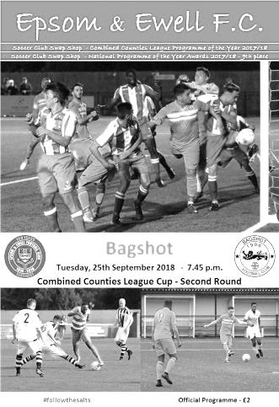
Epsom progress without reaching top gear

To call our single goal League Cup win over Bagshot a great performance would not be telling the truth, although it must also be reported that we restricted the opposition to very few chances and on another day would have extended our "three goals a game" scoring record to a sixth match. Instead our inability to take chances on this occasion kept this match competitive for longer than it should have been.

Another reason for this was as a result of a fine display from the young visiting keeper Ben Roberts, who made three really good saves and kept the match competitive, although could do nothing about the winning goal; a superb Lloyd Connelly near post header from a Liam Roberts delivery that found the top corner of the net in first half injury time.

In terms of our own personnel, we fielded our fifth different keeper of the season, although it was a regular face as last year's Player of the Year Conor Young was back between the posts. Luke Gaffney made his first appearance for nearly four years at left back for the absent Reisse Griffin and Steve Betancourt was back in defence at the expense of Kieran Wright who was on the bench. The only other change came with the reinstatement of Sean White to the starting eleven in place of Kieran Campbell. Interestingly our hat trick hero against Bagshot four weeks previously, Taryn Smith, was only on the bench, but in fairness he had been unavailable for our previous match.

The first action of the match resulted in a yellow card as Louis Robson was the recipient of a harsh decision after he had brought down Roberts on the edge of the area with just 8 minutes on the clock. Then the wall wasn't placed back anywhere near the required ten yards (when it is easy to work this out if the free kick is on the edge of the box) and Adam Heagney's free kick was blocked by the wall. Roberts headed wide from an offside position after a good delivery by White before picking up what looked like an equally harsh yellow when bringing down an attacker on the edge of his own box on the quarter-hour. However, the visitors' delivery from wide out was too deep and went over everyone.

We were spending a lot of time in possession during the match, but a lot of it wasn't hurting the visitors who appeared fairly well set up at the back. Occasionally though we produced some moments of real quality and some nice interplay between Heagney and Endrit Dobraj resulted in a dangerous low cross to the near post which was cleared away at the last minute. Minutes later Heagney sent a deep ball to White who laid it back for Dobraj to deliver. Scott Murphy flicked it on and Roberts then retrieved the ball, squaring it for Bobby Bennett who then struck wide from eight yards.

We were looking quite dangerous at this point Gaffney made a good run to the touchline but the pull back was cleared just in time, before a deep Heagney free kick a minute later was missed by some players at the far post, only to hit one of them inadvertently and fell for Bennett to net from close range, but the whistle had blown for a foul somewhere within the crowd of players.

We then had a strange incident in the 38th minute when a Bagshot player was flagged offside and

everyone stopped with one of our players picking up the ball. However, the referee hadn't actually blown the whistle at this point and there was confusion for a while before the referee sensibly decided to award the free kick in our favour for the original offside. It seemed to annoy the opposition a little though and the game became a little niggly. Then in the 45th minute a deep White cross-shot was half saved by Roberts but the ball fell to Murphy and although he was a little wide, his shot was on target and had plenty of power but was superbly blocked for a corner. His reward for this save was precisely nothing as we then scored from the subsequent corner and went off at half time, probably slightly relieved that we had at last broken the deadlock; something we had failed to do by the half in our previous encounter at Calthorpe Park.

The second half opened up with a long range strike from Roberts that just cleared the bar and a horrible challenge through the back of White for which Sam Taylor was very fortunate to avoid a booking, especially after the two much softer looking cards in the first half. Young was then in action, clearing after a long kick was flicked on, but we were soon on the attack again and Heagney sent a corner in that caused panic and Bennett's shot was then blocked on the line by Taylor.

Then Bennett had another chance when he broke through on the right wing and as he cut in on goal it looked as though he was caught in two minds and shot across goal, missing the far post by a few inches and also being just ahead of the incoming White by a similar distance! Then Connelly was unable to force a loose ball in at the far post, before a Roberts corner was delivered to the far post where White hit the low shot which Bennett cleverly dummied, although the defender wasn't distracted and still managed to clear the ball off the line.

Smith entered the fray and was quickly into the action after Roberts squared a pass from the right for him, but instead of calmly finishing from just eight yards out, he snatched at the shot and smashed it straight at the advancing keeper. In the 79th minute Young had to make his first save when substitute Samuel Herman got around the back of Dobraj, but he was well positioned to make the save. Two minutes later Bennett received another great crossfield pass and cut in on goal, laying the ball into the path of Gaffney who struck firm and low from about 8 yards out, only to see Roberts make a stunning save with his left hand to divert the ball for a corner. It was the best save I had seen at an Epsom match for some considerable time.

There was still time for one final chance after 85 minutes when Smith broke through on the right wing and rounded Roberts, but although his pull back found our own Roberts, he decided to take an extra touch when an open goal was waiting and by the time he struck at goal, Taylor was there to block on the line again, probably with both arms, but the referee and more relevantly the Assistant who had a better view, appeared not to notice this.

The final whistle blew soon after and we were in the hat for the last 16. I must admit to having been slightly underwhelmed by the match, but looking back through my notes, there was a lot more content that had originally seemed the case and whilst maybe we should have scored a few more, we have found the net on a substantial number in recent matches and days like this will occur from time to time.

After the match Murphy referred to the fact that the visitors came with no ambition, and bearing in mind that they had conceded eight goals in the last week it was probably very likely that their main aim was damage limitation, but the roles have changed this year. We are one of the big fish in this division and we may well encounter similar tactics in the future, quite possibly this weekend when we visit Fleet Spurs.

Epsom and Ewell: Conor Young, Endrit Dobraj, Luke Gaffney, Lloyd Connelly, Steve Betancourt, Adam Heagney, Sean White, Scott Murphy (c), Bobby Bennett, Elliott Thompson, Liam Roberts

Subs: Taryn Smith for White (71), Theo Campbell for Thompson (71),
Kieran Wright for Dobraj (91)

From behind the goal
Fleet Spurs 2-3 Epsom & Ewell
Combined Counties League - Saturday 29th September 2018

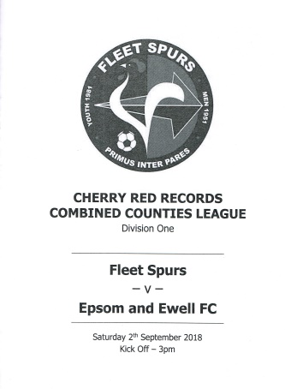
Subs get Salts out of the doghouse at Kennels Lane

One of the most unusual matches in recent club history took place on our first ever visit to Kennels Lane; the home of Fleet Spurs, as we recovered a two goal deficit on a poor surface to score three times in the last twenty minutes and grab victory from the jaws of defeat.

Bearing in mind our opponents league position of second from bottom, a defeat here would have been the worst ever result in our Senior history and we appeared to be sleepwalking towards it for much of this match. As with our recent narrow win against Cove we looked disjointed and dispirited for much of the match, although credit should also be given to the players for digging deep when they really needed to, with a particular mention to Captain Scott Murphy who led by example and drove his team forward during that difficult but memorable second half.

The first half display does not make for pleasant reading, but I have to start by listing at the substantial number of regular first team players who were unavailable for this match. Reisse Griffin, Elliott Thompson, Liam Roberts, Bobby Bennett and of course the recently departed Kieran Campbell were all absent and I just hope that they all had good reasons. However, this decimated our attacking options and Neil Grant was forced to name three players on the bench who had not made an appearance between them so far this season.

The opening fifteen minutes of the match took a familiar pattern as we chased our fourth straight win, with our team holding the majority of possession across the middle of the park. Murphy along with Adam Heagney and Ryan Sullivan who was back after injury were in control. Unfortunately, and I don't know whether it was a recurrence of his previous injury or a new one, but Sullivan was unable to continue after just 18 minutes with Joshua Caulcrick taking his place.

The first thing to check was whether Caulcrick could stay on the pitch for longer than the seven minutes he managed on his one previous appearance for the club against Abbey Rangers back in February when he had been sent off! This was achieved and the new introduction, appearing to play slightly further forward that the man he had replaced, began to show some good touches. Around this time we had our first real chance of the match when a ball from the left reached Sean White but his attempt at what appeared to be a side footed lob went horribly wrong and dribbled towards their keeper and skipper Mark Appleby from around twelve yards out.

White turned provider a few minutes later when his cross was hacked away from Theo Campbell by Victor Mudonni at the very last minute as Campbell, making his first start, would have had an easy close range header otherwise. White then supplied Taryn Smith whose shot was parried by Appleby, but the home side then signalled a little intent of their own with a dangerous attack that went twice across our six yard box before being cleared.

Campbell spoilt a good run with a back heel that conceded possession and this was indicative of the first half as we were creating very little and appearing to think that the goal would just come eventually. When it did though, it was at the other end as Tom Chillery found Jamil Olweny on the

left and his strike from just inside our penalty area flew into the top corner giving Conor Young no chance in the 41st minute.

This had been a dreadful half, even before the goal had been conceded, but worse was to follow. Although White made a chance for himself which was saved and then glanced a header just wide from an Endrit Dobraj delivery from the right, we then conceded a second goal in the 54th minute when a harmless looking long ball was pumped forward. I saw Young going towards the ball before then speeding up to reach it; maybe it didn't bounce through or maybe he thought a defender was going to clear it. Either way, by the time he got there, Chillery and a defender were also there. Young tried to gather but appeared to be nudged and lost the ball which was fed in from the edge of the box for former Ash United striker Karl Dallaway to tap into the empty net.

This was a complete disaster and every alarm bell was ringing loudly now. We had a great chance to pull a goal back minutes later when Luke Gaffney put in a great cross to Murphy. His shot was then blocked by a defender from only a few yards out, the ball going across to Campbell who then scuffed the loose ball at goal with his admittedly weaker foot and it was cleared off the line. This was followed by a deep right wing cross that Caulcrick met with his head just six yards out but managed to direct his header over the bar!

Changes were made in the 62nd minute with Germaine Jeannoel and the recently signed Oliver Martinez joining the fray. Both would have an enormous say in the destination of the points.

As the home side began to drop a little deeper trying to protect their lead, we pounced in the 72nd minute after a long ball to Jeannoel put him through on the right, but not too wide out and he finished clinically, curling his low right footed shot just inside Appleby's near post from twelve yards. There was a suspicion of offside based on the reaction of the defenders and while they were rattled we broke through again just two minutes later when Smith played a clever pass into the path of White and he drilled his shot across Appleby's goal and in off the far post from a similar place to our first goal.

74 minutes in and it was suddenly game on again. We appeared revitalised and Murphy saw his header from Heagney's corner well saved. Next to try were Dobraj and Smith who linked well, and the latter's shot was poked at goal from six yard out only to be repelled by Appleby's shins.

Martinez then delivered a deep cross to White at the far post who struck at goal with the ball coming off the outside of the joint of post and bar. Then from another Heagney corner Smith failed to contact with his head from a couple of yards out. However, there was one more twist to come as Martinez delivered from the left in the 92nd minute. His ball in was controlled by Jeannoel about six yards out in the near post area and he turned and fired the ball in for the winner.

This match so nearly became the banana skin I predicted in my preview. It is no longer possible to look at teams in this league and think that we have a right to be superior to them just by being there, which appears to have been the case recently against Bagshot, Cove and now Fleet Spurs. Our next few matches are much tougher on paper and we will have to improve massively if we are to remain in a strong position at the end of the month and will need to be switched on for the full 90 minutes against every opponent because if not, then as it nearly did here at Kennels Lane, it will come back to bite us.

Epsom and Ewell: Conor Young, Endrit Dobraj, Luke Gaffney, Lloyd Connelly, Steve Betancourt, Adam Heagney, Scott Murphy (c), Taryn Smith, Theo Campbell, Sean White

Subs: Joshua Caulcrick for Sullivan (18), Germaine Jeannoel for Campbell (62),
Oliver Martinez for Gaffney (62)

This Day in History - 6th October
Date | Day | Competition |  | Opponents |  | Scorers
06/10/28 | Sat | Amateur Cup 1q | A | Aquarius | 4-3 | F.Behn (3), J.Parr
06/10/34 | Sat | Amateur Cup 1q | H | Merton | 4-1 | E.Hannam (2), M.Wiggins, R.Marlow
06/10/45 | Sat | London League | H | Vickers Armstrong | 5-0 | S.Tingey (2), A.Fisher (2), E.Watkins (pen)
06/10/51 | Sat | Corinthian League | A | Chesham United | 2-4 | R.Lomax, B.Goddard
06/10/56 | Sat | Corinthian Memorial Shield 1 | H | Worthing | 3-1 | J.Bangs (2), D.Hermitage
06/10/62 | Sat | Corinthian League | A | Wembley | 2-0 | E.Arnall (2)
06/10/73 | Sat | Surrey Senior League Charity Cup 1 | A | Chobham | 2-2+ | C.Rose, P.O'Connell
06/10/79 | Sat | Isthmian League 1 | H | Farnborough Town | 0-1
06/10/81 | Tue | F.A. Cup 2q replay | H | Croydon | 4-0 | T.Tuite (2), M.Spratt, S.Hill
06/10/84 | Sat | Isthmian League Premier Division | H | Bishop's Stortford | 0-0
06/10/87 | Tue | F.A. Trophy 1q replay | A | Bracknell Town | 2-0 | B.Perkins, J.Richardson
06/10/90 | Sat | Isthmian League 2s | A | Hungerford Town | 1-1 | L.Harding
06/10/92 | Tue | Isthmian League 3 | H | Thame United | 0-1
06/10/98 | Tue | F.A. Cup 2q replay | H | Banbury United | 0-1
06/10/12 | Sat | Combined Counties Premier Division | H | Sandhurst Town | 4-0 | R.Burns, D.Marvell, A.McGregor, K.Hough
Historical Decades
Date | Day | Competition |  | Opponents |  | Scorers
90 years ago – Epsom Town F.C.
06/10/28 | Sat | Amateur Cup 1q | A | Aquarius | 4-3 | F.Behn (3), J.Parr
80 years ago – Epsom F.C.
08/10/38 | Sat | Friendly | A | Kingstonian | 4-2 | A.Curtis (2), J.Kinsela, R.Forbes
70 years ago – Epsom F.C.
09/10/48 | Sat | Amateur Cup Preliminary Round replay | H | Chertsey Town | 2-1 | F.Chitty, J.Collins
60 years ago – Epsom F.C.
04/10/58 | Sat | Corinthian League | A | Chesham United | 1-3 | T.Wackett
50 years ago – Epsom & Ewell F.C.
05/10/68 | Sat | Amateur Cup 1q | A | Cobham | 1-0 | G.Hemphrey
40 years ago – Epsom & Ewell F.C.
07/10/78 | Sat | Isthmian League 1 | H | Walton & Hersham | 2-0 | T.Tuite, R.Breen
30 years ago – Epsom & Ewell F.C.
08/10/88 | Sat | F.A. Vase  Preliminary Round | A | Chatham Town | 5-0 | B.Perkins (2), C.Walcott, C.Hadingham, G.Smith
20 years ago – Epsom & Ewell F.C.
06/10/98 | Tue | F.A. Cup 2q replay | H | Banbury United | 0-1
10 years ago – Epsom & Ewell F.C.
07/10/08 | Tue | Combined Counties Premier Division | H | Chessington & Hook United | 3-2 | D.Marvell, R.Burns (2)

History Corner – 6th October
90 years ago today we were at home to Aquarius in the Amateur Cup, defeating them 4-3 with a hat trick from Freddie Behn and the other goal from Jack Parr. But who were they? Well, there were many works sides back then with employees being expected to play for their team; something that would give us trouble in the thirties when we tried to use staff from Epsom Manor Hospital, but this team were the representative side of the Water Board, which before privatisation in the eighties was one big entity, and they played in Honor Oak. However, for Amateur Cup ties, the home side were required to be able to collect admittance money and those who couldn’t were expected to concede home advantage, which was the case here.

70 years ago this week we welcomed Chertsey Town to West Street for the very first time as we resolved an Amateur Cup tie 2-1 in our favour, following a 2-2 draw after extra time at Alwyns Lane seven days previously. This result was achieved despite an injury to Jimmy Emblem that left our boys down to ten men after just three minutes. Our goals came from future two-time Manager Fred Chitty and from Jackie Collins, whose brother Geoff had played for us pre-war before losing his life in the conflict. (see programme left)

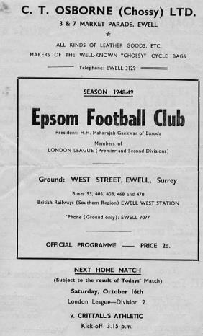
62 years ago today we hosted Worthing at West Street in a Corinthian League Memorial Shield match. This was their equivalent of the League Cup and we eased through by three goals to one with Dave Hermitage finding the net, while new player Johnny Bangs scored the other two. Bangs had announced himself upon the scene when scoring a hat trick on his debut at Maidstone United a couple of weeks previously and would go on to set a club record by scoring in all of his first ten matches for us, registering 23 in that time and eventually finishing with 53 goals; the third highest mark in club history.

56 years ago today two goals from Edward ‘Taz’ Arnall, an Australian player, were enough to defeat Wembley in a League match at Vale Farm. Whilst this was a decent win at a difficult time for the club, the real point of interest here is that it would take us 46 more years before we would win there again, despite frequent visits over that time!

37 years ago today we defeated Isthmian League Premier Division Croydon 4-0 in an F.A. Cup replay. If we hadn’t, you might not be reading this now, as I had decided after reading the local paper reports for about a year that if we won that match, I would go to watch the next round and found myself enjoying it so much that I’m still here now! Tommy Tuite scored twice, while Malcolm Spratt and Steve Hill scored the others, but there would be no happy ending as Hastings United defeated us 4-2 in the next round and went on to reach the First Round Proper.

30 years ago this week we made our first appearance in the F.A. Vase for ten years and visited Chatham Town’s Maidstone Road ground, where we won very comfortably by five clear goals. Further wins against Banstead Athletic, Three Bridges and Wick (after a replay) followed, all of which required extra time before we went out in the last 32, also after extra time to Hailsham Town, which was the exact stage we had reached in our previous entry back in 1978. We have only reached that round once since, back in 2009/10.

How we stand – Locally and Nationally – inc Sat 29/09/18
Here is the latest update on where we all stand. As advised in our previous issue, there are 28 promotion places currently available at Step Six, with 358 teams battling away for those spots. The Champions of each League are guaranteed a promotion, with the best nine runners-up also going up. This number may well rise over the course of the season, but for now it remains at 28.

I summarised the 19 Step Six Leagues recently. Here they are for the final time with their codes.

Combined Counties Division One: (CCL) - Southern Counties League East Division One: (SCEFL) - Southern Combination League Division One: (S.Comb) - Wessex League Division One: (Wess) - Hellenic League Division One East and Hellenic League Division One West: (HellE & HellW) - Western League Division One: (Western) - South West Peninsula League: (SWP) - Spartan South Midlands League Division One: (SSML) - United Counties League Division One: (UCL) - Midland League Division One: (Midland) - West Midlands (Regional) League Division One: (W.Mids) - East Midlands Counties League Division One: (E.Mids) - Northern Counties East League Division One: (NCEL) - Eastern League Southern and Northern Division: (EastS) & (EastN) - North West Counties Northern Division: (NWCN) & (NWCS) - Northern League Division Two: (Northern)

Below is our current League table sorted by points per game and across the page we have the overall top ten and the 28 clubs who would go up if the season ended right now. Last time I did these tables we were 51st Nationally, but we are now up to 37th thanks to that late win at Fleet Spurs.

Bedfont & Feltham, currently holding the runners-up spot in our League have the 15th best record of the 19 second placed teams. Our league is so competitive right now that it may well prove to be just the Champions that go up, but I’ll keep updating the position here while we remain involved.

Combined Counties League Division One Table – by PPG
 | Pld | W | D | L | Pts | GD | PPG | Pos
Farnham Town | 10 | 8 | 1 | 1 | 25 | +18 | 2.50 | 1
Bedfont & Feltham | 9 | 6 | 3 | 0 | 21 | +29 | 2.33 | 2
Epsom & Ewell | 9 | 7 | 0 | 2 | 21 | +15 | 2.33 | 3
Frimley Green | 8 | 5 | 3 | 0 | 18 | +8 | 2.25 | 5
Sheerwater | 8 | 5 | 2 | 1 | 17 | +9 | 2.13 | 6
Dorking Wanderers Reserves | 10 | 6 | 3 | 1 | 21 | +11 | 2.10 | 4
AC London | 9 | 5 | 2 | 2 | 17 | +7 | 1.89 | 7
Ash United | 10 | 4 | 4 | 2 | 16 | +8 | 1.60 | 8
Chessington & Hook United | 10 | 5 | 1 | 4 | 16 | 0 | 1.60 | 9
British Airways | 9 | 4 | 2 | 3 | 14 | -2 | 1.56 | 10
Tooting Bec | 9 | 4 | 1 | 4 | 13 | 0 | 1.44 | 11
Sandhurst Town | 8 | 3 | 1 | 4 | 10 | -7 | 1.25 | 13
Godalming Town | 9 | 3 | 1 | 5 | 10 | -6 | 1.11 | 12
Eversley & California | 8 | 2 | 0 | 6 | 6 | -8 | 0.75 | 14
Kensington Borough | 9 | 2 | 0 | 7 | 6 | -12 | 0.67 | 15
Bagshot | 10 | 2 | 0 | 8 | 6 | -34 | 0.60 | 16
FC Deportivo Galicia | 9 | 1 | 2 | 6 | 5 | -7 | 0.56 | 17
Fleet Spurs | 8 | 0 | 0 | 8 | 0 | -14 | 0.00 | 18
Cove | 8 | 0 | 0 | 8 | 0 | -15 | 0.00 | 19

Step Six Table – by PPG – Top 10
 | Which League? | Pld | Pts | GD | PPG | League Pos.
Selston | E.Mids | 9 | 27 | +25 | 3.00 | 1
AFC Stoneham | Wess | 6 | 18 | +22 | 3.00 | 2
Easington Sports | HellW | 5 | 15 | +17 | 3.00 | 1
Cheltenham Saracens | HellW | 4 | 12 | +15 | 3.00 | 2
Tavistock | SWP | 10 | 28 | +30 | 2.80 | 2
Welling Town | SCEFL | 10 | 28 | +18 | 2.80 | 1
Sherwood Colliery | E.Mids | 9 | 25 | +29 | 2.77 | 2
Heather St Johns | Midland | 8 | 22 | +26 | 2.75 | 2
AFC Varndeanians | Scomb | 8 | 22 | +18 | 2.75 | 1
Wodson Park | SSML | 7 | 19 | +13 | 2.71 | 2
Epsom & Ewell | We are 37th | 9 | 21 | +15 | 2.33 | 3

Step Six Table – The 28 Promoted Clubs if the season ended today
The 19 Champions – Based on current PPG
 | Which League? | Pld | Pts | GD | PPG | League Pos.
Selston | E.Mids | 9 | 27 | +25 | 3.00 | 1
AFC Stoneham | Wess | 6 | 18 | +22 | 3.00 | 2
Easington Sports | HellW | 5 | 15 | +17 | 3.00 | 1
Tavistock | SWP | 10 | 28 | +30 | 2.80 | 2
Welling Town | SCEFL | 10 | 28 | +18 | 2.80 | 1
Heather St Johns | Midland | 8 | 22 | +26 | 2.75 | 2
AFC Varndeanians | Scomb | 8 | 22 | +18 | 2.75 | 1
Wodson Park | SSML | 7 | 19 | +13 | 2.71 | 2
Melton Town | UCL | 7 | 19 | +13 | 2.71 | 1
May & Baker Eastbrook | EastS | 6 | 16 | +16 | 2.66 | 3
Black Country Rangers | W.Mids | 10 | 26 | +19 | 2.60 | 1
Thame Rangers | HellE | 5 | 13 | +10 | 2.60 | 1
Billingham Town | Northern | 9 | 23 | +21 | 2.55 | 3
Harleston Town | EastN | 11 | 28 | +25 | 2.54 | 1
Longridge Town | NWCN | 10 | 25 | +28 | 2.50 | 2
Farnham Town | CCL | 10 | 25 | +18 | 2.50 | 1
Winterton Rangers | NCEL | 10 | 24 | +21 | 2.40 | 1
Cheddar | Western | 7 | 16 | +10 | 2.28 | 3
Abbey Hulton United | NWCS | 11 | 24 | +8 | 2.18 | 1
The 9 Best Runners-Up
Cheltenham Saracens | HellW | 4 | 12 | +15 | 3.00 | 2
Sherwood Colliery | E.Mids | 9 | 25 | +29 | 2.78 | 2
Lutterworth Town | UCL | 6 | 16 | +24 | 2.67 | 2
Broadfields United | SSML | 6 | 16 | +9 | 2.66 | 6
Tividale | W.Mids | 10 | 25 | +25 | 2.50 | 2
Chester-le-Street Town | Northern | 10 | 25 | +16 | 2.50 | 1
Erith & Belvedere | SCEFL | 8 | 20 | +18 | 2.50 | 2
Carlisle City | NWCN | 11 | 27 | +11 | 2.46 | 1
Exmouth Town | SWP | 9 | 22 | +21 | 2.44 | 6
Centre page for results

Centre page for results

Sheerwater F.C. – History
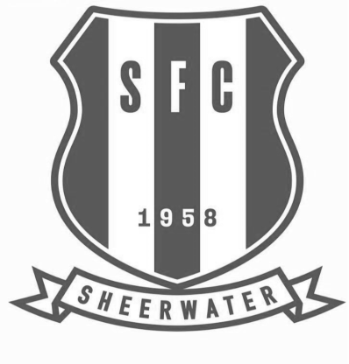

The London County Council started to build Sheerwater Estate in 1948 for families that wanted to move out of London and start a new life in Surrey.

Around 1,380 houses were built at a cost of approximately £3 million. This prompted a community spirit from the early days, and football being the number one sport, came into effect when groups of men started having a kick around at the Sheerwater Recreation Ground, using their coats for goal posts.

Sheerwater Football Club was founded in 1958 by early members of the club, the late John French (also player), Stan West, Ken May, Bill Hilleard, Herbert Taylor (also player), Syd Morris, Derrick Thomas, Jim McDermott and players Dennis Hill, John Murray, Micky Wedge, Chris Robinson, Jose Garcia, Tony Minchinton, Don Stevens, Michael French, Jim Kelly, to name a few.

Sheerwater joined the local Woking & District League. We then progressed through the Divisions and obtained Intermediate status in the Surrey Intermediate (Western) League in the 1967-68 season. The club then progressed to senior level, and we were promoted to the Surrey Senior League for the 1972-73 season with a highest finish of 6th in the 1974-75 season.

In 1978 following the loss of clubs to the London Spartan League, Hampshire clubs were admitted to the Surrey Senior League with the title of the competition eventually becoming the Combined Counties League. In 1981-82 the League had reached 22 members, and as a consequence was split into East and West divisions. In a dreadful season with only one win and one draw the club finished bottom of the East division, 16 points behind Clarion and both Sheerwater and Clarion were relegated to the newly formed Surrey Premier

league.

In our first season in this new league we had a highest position of 5th in 1982-83. However in 1984-85 we finished only above the bottom side Heath End Wanderers and a further relegation followed. Unfortunately the vacancy at the lower level was a position in the Surrey Intermediate (Eastern) Division. Fortunately after one season in the Eastern Division we were allowed to transfer to the Surrey Combination Premier Division for the 1986-87 season, but we were relegated at the end of the season.

After twice finishing third, we were Champions of Division One in 1989-90 and promoted to the Premier Division for 1990-91, finishing in a mid-table position. However in June 1991 The Surrey Combination and Surrey South Eastern Intermediate Leagues merged, but we were able to move sideways to the Surrey Intermediate (Western) League. This was only for one season as we achieved promotion back to the Surrey Premier League. Our stay was, however, for only one season as we finished above bottom club Ashtead, only on goal difference, and were relegated once more. Yet again this was only for one season.

In 1994-95 we were back in the Surrey Premier League and finished 9th. After many discussions the Surrey Premier League became the first division of the Combined Counties League for the season 2003-04.

We are still in the Division One League today, striving to maintain league standards with a small budget with few committee members and local helpers that maintain a good standard for the League. Although at present we are failing to meet the required Grade G with floodlights to stay in the League but we are part of the new Sheerwater Regeneration Programme that does not include a Recreation Ground or Athletic Club.

We will be moving to a new facility on Sheerwater at the Bishop David Brown School in 2020 that will be up to the correct grading to continue in the Combined Counties League. Due to this delay the club has now agreed a two season ground share with Vanarama club Woking FC.

Combined Counties League Premier Division
Opponents All-time Records
inc Saturday  29th September | P | W | D | L | F | A | PPG | GD | Best  Win | Worst  Loss
Bedfont & Feltham | 2 | 2 | 0 | 0 | 13 | 3 | 3.00 | +10 | 9-2 | -
AC London | 1 | 1 | 0 | 0 | 6 | 0 | 3.00 | +6 | 6-0 | -
Bagshot | 2 | 2 | 0 | 0 | 4 | 0 | 3.00 | +4 | 3-0 | -
FC Deportivo Galicia | 1 | 1 | 0 | 0 | 3 | 0 | 3.00 | +3 | 3-0 | -
Tooting Bec | 1 | 1 | 0 | 0 | 3 | 1 | 3.00 | +2 | 3-1 | -
Fleet Spurs | 1 | 1 | 0 | 0 | 3 | 2 | 3.00 | +1 | 3-2 | -
Frimley Green | 10 | 8 | 1 | 1 | 32 | 5 | 2.50 | +27 | 7-1 | 0-1
Sheerwater | 4 | 2 | 2 | 0 | 8 | 2 | 2.00 | +6 | 3-0 | -
Godalming Town | 3 | 2 | 0 | 1 | 4 | 5 | 2.00 | -1 | 2-1 | 0-3
Farnham Town | 17 | 9 | 4 | 4 | 30 | 25 | 1.82 | +5 | 3-0 | 1-4
Ash United | 19 | 10 | 3 | 6 | 48 | 31 | 1.74 | +17 | 6-0 | 0-3
Cove | 35 | 16 | 9 | 10 | 78 | 57 | 1.63 | +21 | 7-0 | 1-6
Chessington & Hook | 29 | 12 | 9 | 8 | 59 | 44 | 1.55 | +15 | 6-0 | 1-3
Sandhurst Town | 15 | 6 | 0 | 9 | 27 | 28 | 1.20 | -1 | 4-0 | 1-3
Dorking Wanderers Res | 1 | 0 | 0 | 1 | 3 | 5 | 0.00 | 0 | - | 3-5
British Airways | 0 | 0 | 0 | 0 | 0 | 0 | 0.00 | 0 | - | -
Eversley & California | 0 | 0 | 0 | 0 | 0 | 0 | 0.00 | 0 | - | -
Kensington Borough | 0 | 0 | 0 | 0 | 0 | 0 | 0.00 | 0 | - | -

Previous Managers
Following on from the long running A-Z series of opponents, I thought it was now time to cover our history in another area; that of our Club Managers and their forerunners in history.

I hope you enjoyed the opening segment. We now move on to the era of the Player / Coach!

Pat Lynch – Player / Coach 1952-1955

In 1952 the club appointed an extremely well-known person in Amateur circles. Pat Lynch had been good enough to represent Isthmian League Tufnell Park at the tender age of 16 and following the war had become Captain of Golders Green, who changed their name to the much better known Hendon that we know today. He was an England Schoolboy International in his earlier years and played in the club’s two famous Amateur Cup Semi-Finals against the mighty Pegasus, where they were denied a place at Wembley by a penalty save with the University side going on to win the Trophy in front of Amateur football’s very first 100,000 crowd.

As Captain of that team Pat was that close to lifting the holy grail for Amateur footballers, but time waits for no man and he obviously wished to get into Coaching, joining us just over a year after those famous matches.

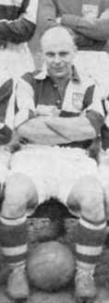
Even so, this was still a major coup for the club. Pat brought a wealth of experience and introduced a playing formation apparently used by Hendon that had been copied by Arsenal. He also brought a new innovation with him, the tactics board! Better still was that he was only 31, despite going bald prematurely, which meant that he would become not just a Coach but would also strengthen the playing side.

The local papers were complimentary. One wrote: “Pat has had some very good instructors including Ted Drake and Laurie Scott, plus many years of first class football "I am very optimistic about the future at Epsom.” Pat is pictured here in November 1952.

Of course, big names like this attract other players and Frank Lee joined from much larger Walton & Hersham where he had recently scored twice in their Amateur Cup Quarter-Final defeat. Obviously we still had a superb striker Bill Goddard and he would write the headlines this season. We would later see a couple of former Hendon players joining the club in Bobby Avis and Glyn “Chick” Hinshelwood. Also another Isthmian League player Brian Brumwell, who played table tennis to a very high standard and was good enough to enter the World Championships! For home matches Brumwell and his wife Sheila used to get the train in from East London and would meet up with Lynch coming down from North London where they would then get the train to Ewell from Waterloo as neither drove.

The season started quite well with four straight league wins and a narrow defeat in the

F.A. Cup by mighty Dulwich Hamlet, and even that was a replay, following a 2-2 draw at West Street in front of over 3,000 spectators. These were the halcyon days of football when crowds were massive. Goddard would already have 11 goals by the end of September and would go on to score 54 goals during this season, including the incredible feat of five hat tricks in a row. We at Epsom know that Reg Marlow also achieved this feat back in 1926/27 but the papers didn’t, and lauded Goddard’s feat as a world record, when it wasn’t even a new club record!

That aside though, it was an amazing achievement and it could be argued that it was the greater of the two as we were playing at the higher Corinthian League level as opposed to the Surrey Senior League, whilst Marlow had also missed one match in the middle of his five match scoring run with flu, against Isthmian League Woking.

The season was an exciting one with home and away wins against the biggest team in our League, Champions Hounslow. We defeated them 4-1 at West Street but the return at Denbigh Road was one of the best performances by an Epsom team in history, as we went a goal up inside thirty seconds and were three up in 14 minutes. We even led 5-0 after 32 minutes against this stellar team full of Internationals, going on to win 6-2, Hounslow’s worst ever defeat in their Corinthian League days.

We would go on to finish third; our highest ever finish in the Corinthian League in our fourteen years there, although Dulwich also ended our County Cup run 4-3 while Dagenham repeated the scoreline in the Amateur Cup. We destroyed local rivals Carshalton Athletic 7-1 on Easter Saturday but this was their only loss in an incredible run that took them from bottom of the table on 7th March, to eventual Champions. They may have had games in hand, but even so, this was still a great sequence of results. More disappointingly, Hounslow also finished above us.

The 1953/54 season was greeted with anticipation but the loss of Goddard didn’t help, followed by defeat in the F.A. Cup to Hounslow and more shockingly in the Amateur Cup at home to minnows Worcester Park. Hounslow also knocked us out of the Memorial Shield (League Cup) and we would only finish tenth. The natives were getting restless but were pacified with a famous run to the Final of the Surrey Senior Cup, where we met Corinthian Casuals after a fantastic battle with Dulwich Hamlet over 240 minutes, with the replay in particular at Sandy Lane of great significance as we trailed 2-0 and looked to be heading out before we forced an extra time winner from Avis.

The Final in front of 6,159 at Selhurst Park didn’t go our way despite being the better side as we were beaten 2-0 with a goal in each half and the less said about the wretched 1954/55 season the better. Lynch was beginning to struggle with injury, while both the First Team and Reserves would finish at the bottom of the League. Matters came to a head on 19th March 1955. With the team having failed to win a League match since the opening day of the season and having crashed out of the League Cup to Uxbridge, Lynch dropped himself to watch the match and see what was going wrong. We then won 2-1 against Maidstone United that day and Pat never played again, choosing to retire in the April of 1955 and returning to Highgate where he lived and ran a toolmaker’s shop with his wife. He died in December 1987 at the age of just 67.

Player Sponsorship
Here is the new list for 2018/19, with new photos showing all of our players and Management that are available for sponsorship.

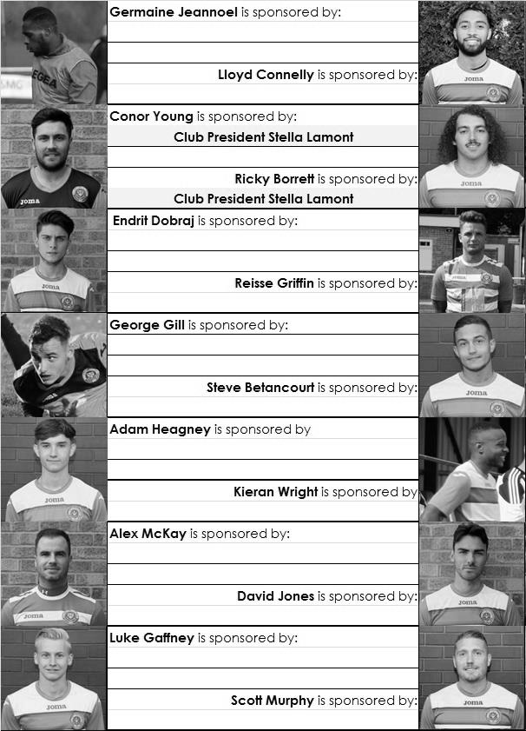

Sponsorship costs just £40 and it is easy to do. Just select a player who has not been previously sponsored and let a Committee Member know that you would like to sponsor them. Beware though. Until we have received the money it is possible for someone to jump in front of you, so don’t delay, sponsor today!

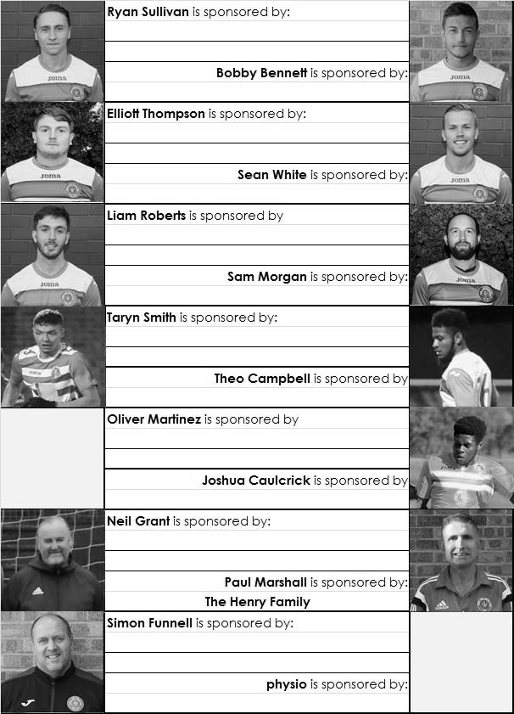

CCL Division One Club Directory
AC LONDON: Telephone: 0208 660 5491 - Colours: Orange/Black/Black
Ground: Whyteleafe FC - 15 Church Road, Whyteleafe. CR3 0AR

ASH UNITED: Telephone: 01252 344264 - Colours: Green with Red Trim/Green/Green
Ground: Shawfields Stadium, Youngs Drive, Shawfields Road, Ash, Aldershot. GU12 6RE

BAGSHOT: Telephone: 01252 623804 - Colours: Yellow/Black/Black
Ground: Fleet Town FC - Calthorpe Park, Crookham Road, Fleet. GU51 5FA

BEDFONT & FELTHAM: Telephone: 0208-890 7264 - Colours: Yellow/Blue/Blue

Ground: The Orchard, Hatton Road, Bedfont. TW14 9QT

BRITISH AIRWAYS: Telephone: 0208-890 7264 - Colours: Sky Blue/Navy Blue/Navy Blue
Ground: Bedfont & Feltham FC - The Orchard, Hatton Road, Bedfont. TW14 9QT

CHESSINGTON & HOOK UNITED: Telephone: 01372-602263 Colours: All Blue
Ground: Chalky Lane, Chessington. KT9 2NF

COVE: Telephone: 01252 543615 Colours: Yellow/Black/Black
Ground: Oak Farm, Squirrel Lane, Cove GU14 8PB

DORKING WANDERERS RES Telephone: 01306 400151 - Colours: Red & White Stripes/ Blue/ Red
Ground: Meadowbank Stadium, Mill Lane, Dorking. RH4 1DX

EPSOM & EWELL Telephone: 01737-553250 - Colours: Royal Blue & White Hoops/Royal Blue/Royal Blue - Ground: Chipstead FC, High Road, Chipstead. CR5 3SF

EVERSLEY & CALIFORNIA Telephone: 0118 973 2400 - Colours: - White & Royal Blue Hoops /Royal Blue/ Royal Blue - Ground: Fox Lane, off Reading Road, Eversley. RG27 0NS

FARNHAM TOWN Telephone: 01252 715305 - Colours: - Claret & Sky Blue /White/ Claret & Blue
Ground: Memorial Ground, Babbs Mead, West Street, Farnham. GU9 7DY

FC DEPORTIVO GALICIA Telephone: 0208 831 9067 - Colours: Royal Blue/Royal Blue/White
Ground: Bedfont Sports FC - Bedfont Sports Club, Hatton Road, Bedfont. TW14 9JR

FLEET SPURS Telephone: 01252 662810 - Colours: Dark Blue with Red Trim/Dark Blue/Dark Blue
Ground: Kennels Lane Farnborough. GU14 0ST

FRIMLEY GREEN Telephone: 01252 835089 - Colours: All Blue
Ground: Frimley Green Recreation Ground, Frimley Green Road, Frimley. GU16 6JY

GODALMING TOWN Telephone: 01483 417520 - Colours: Yellow/Green/Yellow
Ground: Wey Court, Meadrow, Godalming. GU7 3JE

KENSINGTON BOROUGH Telephone: 01372 360151 - Colours: All Blue
Ground: Leatherhead FC – Fetcham Grove, Guildford Road, Leatherhead. KT22 9AS

SANDHURST TOWN Telephone: 01252 878768 - Colours: Red & Black Stripes/Black/Black
Ground: Bottom Meadow, Sandhurst Memorial Park, Yorktown Road, Sandhurst. GU47 9BJ

SHEERWATER Telephone: 01483 772470 - Colours: Royal Blue & White/Royal Blue/Royal Blue
Ground: Woking FC - Laithwaite Community Stadium, Kingfield, Kingfield Road, Woking. GU22 9AA

TOOTING BEC Telephone: 0208 540 8843 - Colours: Black & White Stripes/White/White & Black
Ground: Raynes Park Vale FC – Prince George’s Playing Fields, Grand Drive, Raynes Park. SW20 9DZ

EL Records Premier Challenge Cup
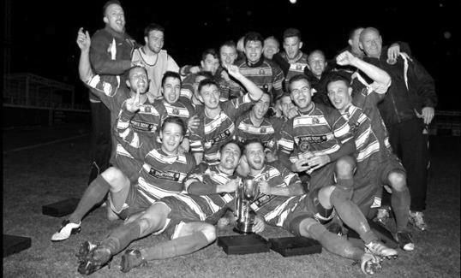
First Round
Camberley Town | 1-3 | Cobham
Horley Town | 0-1 | Chertsey Town
Badshot Lea | 3-1 | Walton & Hersham
FC Deportivo Galicia | 4-1 | Cove
Chessington & Hook United | 2-4 | AFC Hayes
Farnham Town | 1-2 | Southall
Hanworth Villa | 3-1 | Kensington Borough
Second Round
Bedfont & Feltham | 2-0 | Tooting Bec
Sheerwater | 1-0 | Balham
Ash United | 2-3 | Fleet Spurs
Frimley Green | 0-2 | Guildford City
Godalming Town | 2-0 | Dorking Wanderers Reserves
Abbey Rangers | 3-0 | Redhill
FC Deportivo Galicia | 3/10 | AC London
Cobham | V | AFC Hayes
CB Hounslow United | V | Badshot Lea
Hanworth Villa | V | Sandhurst Town
Epsom & Ewell | 1-0 | Bagshot
Sutton Common Rovers | V | Southall
Chertsey Town | V | British Airways
Eversley & California | 1-5 | Knaphill
Banstead Athletic | 4-3 | Colliers Wood United
Spelthorne Sports | 2-1 | Raynes Park Vale

Match and Ball Sponsorships – 2018/19
Opponent | Date | Match Sponsor | Ball Sponsor
Chessington & Hook Utd | 21/08/18 | Club President - Stella Lamont
Beckenham Town (FAC) | 28/08/18 | Building Shop Ltd
Cove | 08/09/18 | EEFC Management Committee
Tooting Bec | 15/09/18 | Building Shop Ltd
Bagshot (LC) | 25/09/18
Sheerwater | 06/10/18 | Paul Merritt
Knaphill U23  (Surrey Premier Cup) | 23/10/18 | Jack Jarman
Frimley Green | 03/11/18
Sandhurst Town (LD1C) | 06/11/18
Kensington Borough | 17/11/18 | Jeff & Arnold Pye
Dorking Wanderers Res | 27/11/18
Godalming Town | 01/12/18
Bedfont & Feltham | 08/12/18
Eversley & California | 29/12/18
Ash United | 12/01/19
Bagshot | 19/01/19
Farnham Town | 02/02/19
British Airways | 16/02/19
AC London | 02/03/19
FC Deportivo Galicia | 12/03/19
Fleet Spurs | 06/04/19
Sandhurst Town | 20/04/19 | Club President - Stella Lamont
unknown |  | (LC) 3rd Round – might be at home
Match sponsorship costs just £60.00!

Sponsorship includes:

Admission, programmes and hospitality for three people.

A full page advert in the programme and mascot for the day (if required).

If you are interested, just speak to a Committee Member,
or drop me an email at: richard.c.lambert@gmail.com

Matches against Sheerwater F.C.
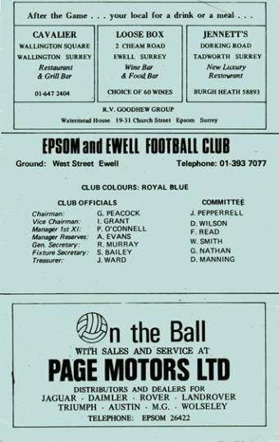
As advised earlier, we have met Sheerwater on just four previous occasions, following our demotion into the Surrey Senior League, just as they were being promoted into it!

Our first meeting came on Saturday 13th October 1973, or 45 years next Saturday (see programme left) and the match resulted in a goalless draw.

Our only visit to the Sheerwater Recreation Ground came on Saturday 2nd March 1974 where a 2-2 draw was the result. Our scorers that day were Barry Jones and our record scorer Tommy Tuite and we would finish runners-up behind all-conquering Westfield with Sheerwater finishing 12th of the 16 clubs, three points ahead of bottom club Frimley Green.

In 1974/75 we were an even better team and they were one of our early conquests as we won 3-0 on Saturday 24th August 1974 (see

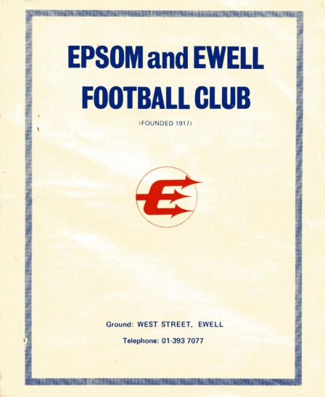
programme right) with goals from Dave Worby, Tuite again and future professional with Millwall amongst others, Trevor Lee.

Our final meeting was on Saturday 3rd May in a match that was switched from Sheerwater Recreation Ground to West Street due to cricketing considerations and the scoreline of 3-0 was repeated, this time with goals from the other future professional with Millwall Phil Walker, along with Alan Webb and Johnny Eales. We became Champions while they finished sixth.

So we recommence battle after a gap of forty-three years. Results went well for us in that period. Can we keep that record up?

Combined Counties League – Division One
Saturday, 6th October 2018 - Kick-off 3.00 p.m.
Epsom and Ewell  (Royal Blue & White hoops) | V |  | Sheerwater  (Red & White Stripes/Red/Red)
Squad | NUMBERS |  | Squad
Conor Young |  |  | Andy Rider
Adam Heagney |  |  | Andrew Charles
Reisse Griffin |  |  | Alex Headland
Lloyd Connelly |  |  | Scott O’Connor ©
Steve Betancourt |  |  | Jamie Doble
Ryan Sullivan |  |  | Neil Roisetter
Liam Roberts |  |  | Rikki Letch
© Scott Murphy |  |  | Thomas Hegarty
Taryn Smith |  |  | Shane Rideout
Elliott Thompson |  |  | Chris Machay
Bobby Bennett |  |  | Shane Cheeseman
Sean White |  |  | Daniel Mills
Germaine Jeannoel |  |  | Ollie McAleese
Endrit Dobraj |  |  | Robbie Wilson
Kieran Wright |  |  | George Dore
Joshua Caulcrick |  |  | Toni Perri
Oliver Martinez |  |  | Ross White
Alex McKay |  |  | Andrew Rothwell
Ricky Borrett |  |  | Luca Scannella
George Gill |  |  | Timmy Taylor
 |  |  | Luke Taylor
Neil Grant | MANAGER |  | Phil Ruggles
Simon Funnell | ASSISTANT |  | Sean Wallace
Sam Morgan | COACHES |  | Tom Davis
REFEREE: H.Rance
ASSISTANTS: C.Kirkby, P.Maskell
Today’s match is sponsored by
long-serving supporter Paul Merritt

OUR NEXT VISITORS TO HIGH ROAD
Knaphill Under 23s
Surrey Premier Cup – Second Round
Tuesday, 23rd October 2018

